Density based Traffic Light System with Emergency Vehicle Prioritization

**2023**

Group-26

AASTU

12/1/2023

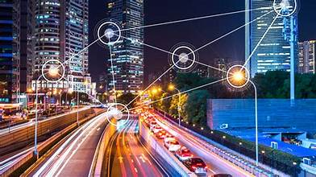



**ADDIS ABABA SCIENECE AND**

**TECHNOLOGY UNIVERSITY**

**INTEGRATED ENGINEERING TEAM PROJECT**

**Density based Traffic Light System with Emergency Vehicle Prioritization**

**Group -26**

**Project Proposal**

|  |  |  |  |  |
| --- | --- | --- | --- | --- |
| **Group**  **No.** | **26** | **Name of Students** | **ID No.** | **Department** |
| **Advisor** | **Dr. Kenatu Angassa** | **Daniel Mekonnen Ejeta** | **ETS0351/13** | **Software** |
| **Title** | **Density based Traffic Light System with Emergency Vehicle Prioritization** | **Etsubdink Hayelom Mengesha** | **ETS0448/13** | **Software** |
| **Lidya Yoseph Asmelash** | **ETS0776/13** | **Electrical** |
| **Gashahun Demise Tilahun** | **ETS0534/13** | **Electrical** |
| **Habtamu Amide Degefa** | **ETS0562/13** | **Civil** |
| **Yoseph Weldemariam Abay** | **ETS1394/13** | **Electromechanical** |
| **Urji Eyasu Mijena** | **ETS1260/13** | **Electromechanical** |
| **Baslel Ephrem Eshete** | **ETS0178/13** | **Mechanical** |
| **Dawit Fitsum Abrham** | **ETS1603/13** | **Environmental** |
| **Fitsum Abrham Temesgen** | **ETS0524/13** | **Chemical** |

**Table of Content**

Abstract 2

1. INTRODUCTION 3

1.1 Background of the project 3

1.2 Statement of the Problem 4

1.3 Objectives of the project 4

1.4 Significance of the project 4

1.5 Expected Outcomes 5

2. RELATED WORKS 5

2.1 SDG Mapping 6

3. MATERIALS AND METHODS 6

3.1 Required Materials 6

3.2 METHOD 7

3.3 Proposed Model 8

4. BUDGET 10

5. PROJECT SCHEDULE 11

6. REFERENCES 12

# Abstract

Traffic jams and delays are frequently caused by traditional traffic signal systems' inability to adjust to the dynamic nature of traffic flow. By dynamically modifying signal timing in response to current traffic circumstances and giving priority to emergency vehicles, this proposal describes a density- and priority-based traffic light system that attempts to overcome these constraints. An intelligent algorithm is employed by the system to dynamically assign the duration of the green light depending on observed traffic patterns, while a network of sensors is used to monitor the density of traffic at each intersection. Furthermore, the system has a priority mechanism that permits emergency vehicles to pass through junctions immediately, guaranteeing prompt response to crucial circumstances. It is anticipated that the suggested approach will greatly lessen traffic jams, increase emergency response times, and optimize traffic flow efficiency. This project will be done with estimated budget of 10,000.00 (Ten thousand Ethiopian Birr from November, 2023 to January, 2024.

# 1. INTRODUCTION

## 1.1 Background of the project

The increasing population in developing countries like Ethiopia leads to issues like heavy traffic rules, accidents, long waiting times, fuel depletion, and money waste. Traffic congestion also contributes to high emissions, impacting local health, shuttles, and animals. It is often associated with blocking emergency vehicles, which could be detrimental to human life. Rapid population growth in cities has led to increased road traffic and increased deaths due to delays in emergency vehicle arrival. To prevent serious human loss, hospitals and fire stations must be present throughout the city to reduce response time. Emergency services like ambulances and fire engines must be on time to prevent loss of life.

As vehicular traffic increases globally, especially in urban areas, smart traffic control becomes crucial. Congestion in traffic is a serious issue, with many vehicles waiting at signals for long periods. This leads to increased consumption and problems for people going to work and business. Traffic signals are prepared for a certain time, but must be changed to avoid loss of time or life. Traffic lights are not functioning properly in some areas, and modern transport is failing to provide a smooth transportation system. Excessive traffic jams affect people, leading to delays in reaching work and home. Urban transportation infrastructure is almost saturated due to lack of land resources, increasing vehicle numbers, and road damage from potholes and pits. This has led to traffic-related problems in urban areas.

The Technology we propose can help by using devices to understand traffic conditions and make necessary decisions. Intelligent traffic management is crucial for proper civilization, and smart, adaptable traffic control systems are preferred over fixed-time systems in developing nations. Helping emergency vehicles escape traffic congestion is essential for reducing human loss. And for that IOT plays a crucial role in traffic management by collecting data from sources like traffic cameras, mobile phones, and road sensors. It provides automatic and intelligent analysis of traffic information on large areas. Modern traffic management is evolving into an intelligent transport system based on IOT, consolidating data, providing near-real-time insights, monitoring operations, and supporting storage. IOT features are dynamic, self-adapting, self-configuring, communication protocols, and integrated into information networks. Sensors detect traffic density, which is fed to micro controllers for action. Many cases result in fatalities on the way to the hospital due to traffic congestion. To avoid this, prioritizing emergency vehicles on the road and ensuring they arrive at the right time to serve the ones in need.

## 1.2 Statement of the Problem

Traffic congestion and delayed emergency response times pose significant challenges to urban safety and well-being. Traditional traffic light systems often fail to prioritize emergency vehicles, leading to delays that can have life-threatening consequences. This project aims to address these issues by developing a smart traffic light system that prioritizes emergency vehicles, ensuring timely arrival at the scene and improving overall road safety.

## 1.3 Objectives of the project

* To design and develop a smart traffic light system that effectively prioritizes emergency vehicles.
* To implement RFID technology for emergency vehicle identification and ultrasonic sensors for vehicle detection.
* To develop an intelligent algorithm to control traffic lights and prioritize emergency vehicles.
* To thoroughly test and evaluate the system's performance in a simulated environment.

## 1.4 Significance of the project

* Reduced Traffic Congestion: By dynamically adjusting signal timing to match real-time traffic patterns, the system effectively minimizes the occurrence of traffic jams, leading to smoother and more efficient traffic flow.
* Enhanced Emergency Response Times: The priority mechanism ensures that emergency vehicles can swiftly navigate through intersections, minimizing delays and enabling them to reach critical situations promptly.
* Optimized Traffic Flow Efficiency: The intelligent algorithm optimizes signal timing to maximize traffic throughput, reducing overall travel times and improving the overall efficiency of the transportation network.

## 1.5 Expected Outcomes

The successful completion of this project is expected to yield the following outcomes:

* A functional prototype of a density- and priority-based traffic light system.
* Quantitative data demonstrating the effectiveness of the DPTLS in reducing traffic congestion, improving emergency response times, and optimizing traffic flow efficiency.

# 2. RELATED WORKS

Many methodologies such as Density based Smart Traffic Light control system, Traffic Control System by using RFID, Smart Traffic control with Ambulance Detection system, Traffic controls for emergency vehicle has been proposed by many authors such as;

**S.M.Kang** , developed an algorithm for the working of the traffic signal using location based

information. In this system, the ambulance gives its location to the nearest traffic signal to control the traffic for clearance of the traffic

**Z.Wang**;designed an architecture of the road at the Traffic Signal. Every traffic signal will have a separate road way for the moving of an Ambulance Vehicle to pass from the Traffic Signal at the time of Emergency

**M.E.Ben Akiva;** implemented a system in which it will evaluate the time taken process for the ambulance to cross at the Traffic Signal. And make automatic time levels for the different path ways for changing of signals at the junction.

**Samantha**; developed a system based on artificial intelligence traffic control system. And also by using of RFID technology, it is implemented in artificial intelligence system for the operation of Traffic Signal.

And by many more like; **S.H.Kim, W.Wang, M.A.Salahuddin, W.H.K.Lam, W.Wang** and **R.F.Benekohal**

These existing methodologies even-though great have a few drawbacks such as operating of a Traffic Signal is not interfaced with a RFID system. And the Sensors are not placed along with the RFID tags. Motivated by these failures, we have proposed an advanced system that aims to handle the traffic signals automatically and helps the emergency vehicle to cross at the traffic signals with ease.

## 2.1 SDG Mapping

This project aligns with Sustainable Development Goal (SDG) 11: Sustainable Cities and Communities. By improving traffic management and prioritizing emergency vehicles, the project contributes to the creation of inclusive, safe, resilient, and sustainable cities and human settlements.

# 3. MATERIALS AND METHODS

## 3.1 Required Materials

The proposed system requires the following hardware: Arduino Mega 2560 ,Arduino nano .RFID reader RC-522,Ultrasonic sensor HC SRo 4, Power-supply (12v,5v,3.3v battery) ,LED lights ,Jumper cables

**Arduino Mega (ATmega2560):**  The Arduino Mega 2560 is a Microcontroller board based on the ATmega2560. It has 54 digital input/output pins (of which 15 can be used as PWM outputs), 16 analog inputs, 4 UARTs (hardware serial ports), a 16 MHz crystal oscillator, a USB connection, a power jack, an ICSP header, and a reset button. It contains everything needed to support the microcontroller, simply connect it to a computer with a USB cable or power it with a AC to-DC adapter or battery to get started. The Mega 2560 board is compatible with most shields designed for the Uno and the former boards Duemilanove or Diecimila

**RFID Reader and RFID Tag**: RFID Reader is a device that has one or more antennas that emit radio waves and receive signals back from the RFID Tag. RFID Tag is a electromagnetic interrogation pulse from a nearby RFID reader device, the tag

transmits digital data, usually an identifying inventory number or information, back to the reader

**LED (Light Emitting Diode):** A Light-Emitting Diode (LED) is a semiconductor light source that emits light when current flows through it.

Electrons in the Semiconductor recombine with electron holes, releasing energy in the form of photons. It will indicates the vehicles for Go, Stop and Ready to go.

**Ultrasonic sensor HC SRo 4:** It is used for detecting the distance to an object using sonar. The HC-SR04 uses non-contact ultrasound sonar to measure the distance to an object, and consists of two ultrasonic transmitters (basically speakers), a receiver, and a control circuit.

## 3.2 METHOD

The project will follow a systematic approach to achieve its objectives:

**Stage 1: Literature Review**

* Conduct an extensive review of existing literature on DPTLS, including theoretical concepts, implementation techniques, and performance evaluation studies.
* Identify key factors influencing the effectiveness of DPTLS, such as sensor placement,signal timing algorithms, and emergency vehicle prioritization mechanisms.

**Stage 2: System Design**

* Develop a system architecture for the DPTLS prototype, including hardware components (sensors, traffic lights, and controllers), communication protocols, and software components (data acquisition, signal processing, and control algorithms).
* Design and implement signal timing algorithms that dynamically adjust green times based on real-time traffic density and emergency vehicle presence.
* Develop a priority mechanism that ensures immediate passage of emergency vehicles through intersections.

**Stage 3: Prototype Implementation**

* Procure and assemble the necessary hardware components for the DPTLS prototype, including sensors, traffic lights, and a microcontroller unit.
* Develop software modules for data acquisition, signal processing, and control algorithm execution
* Integrate hardware and software components to create a functional DPTLS prototype.

**Stage 4: Performance Evaluation**

* Set up a controlled environment to simulate real-world traffic scenarios.
* Evaluate the performance of the DPTLS prototype under various traffic conditions,including varying traffic density, emergency vehicle presence, and different signal timing algorithms.
* Measure performance metrics such as traffic congestion reduction, emergency response time improvement, and overall traffic flow efficiency.

## 3.3 Proposed Model

The Emergency Vehicles like Ambulance passes at the Traffic Signal with the help of a RF Transmitter. The RF Transmitter is built at each side of the four ways of Traffic Signal. When anyone switches on any one side of RF Transmitter, when an Ambulance comes nearer to the Traffic Signal. The Traffic Signal automatically changes into a Green Signal. Therefore, the Ambulance passes from the Traffic Signal. In this project we proposed a new system which is more useful and takes less time to operate and which is more useful to clear the Traffic for Ambulance at the Traffic Signal. To reduce the congestion and unwanted time delays in traffic, an advanced system is proposed. One such advanced technology we implemented in our project is Smart Ambulance using RFID Tags and RFID Readers. This RFID tag is attached to the Ambulance, reader is placed at the Traffic Signal. When the reader reads the tag and gets the input information, when the ambulance comes nearer to the Traffic Signal. And process the operation by using an Arduino Processor Kit to change the Traffic Signal i.e., Red Signal to Green Signal and give way to the Ambulance vehicle at the Traffic Signal.

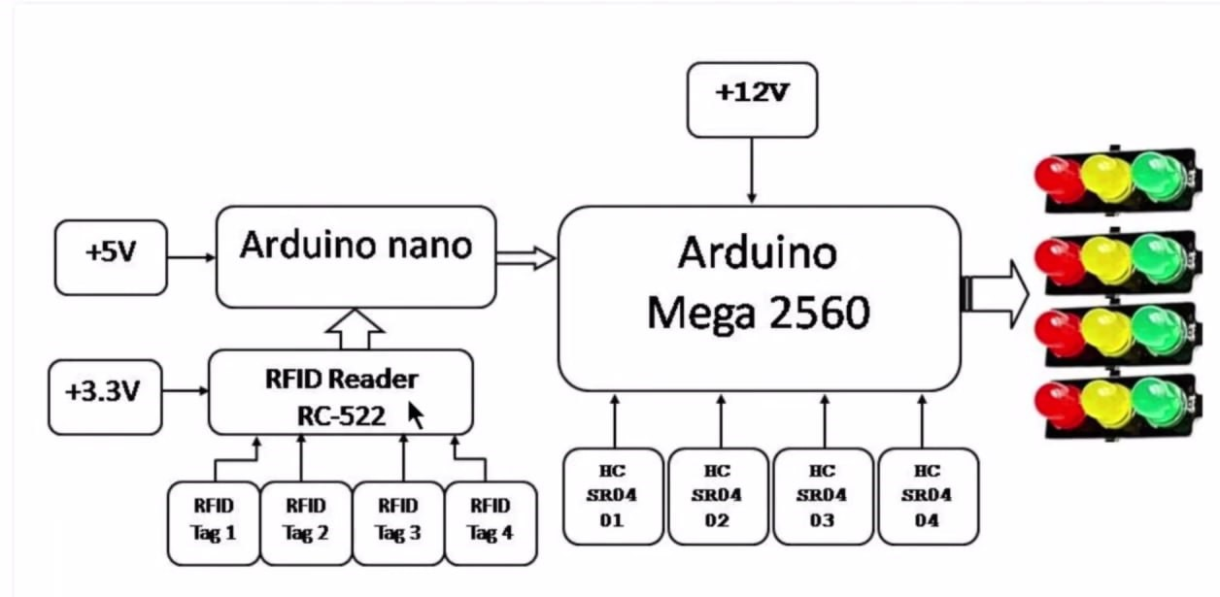

Figure 1 : Block diagram of the Proposed System

Arduino is an open-source electronic platform based on easy-to-use hardware and software. Arduino boards are able to read inputs – light on a sensor, a finger on a button or a message and turn it into an output. Over the years, Arduino has been the brain of thousands of projects. Around this open-source platform, their contributions have added up to an incredible amount of accessible knowledge that can be of great help to novices and experts alike. IR Sensor – Infrared technology addresses a wide variety of wireless applications. The main areas are sensing and remote controls. In the electromagnetic spectrum, the infrared portion is divided into three regions: near infrared region, mid infrared region and far infrared region. Optical wireless communication is done with IR data transmission for short range applications. An infrared sensor emits or detects infrared radiation to sense its surroundings. A RFID system is comprised of two components: RFID Reader and RFID Tag. The RFID reader consists of an antenna to emit high-frequency EM waves to a tag.

RFID Tag can be either passive or active. Active Tags are powered by batteries while the passive RFID tags are powered by the energy from the reader’s interrogating EM waves. The tags are available in different forms of shapes like cards, tags, key fobes or stickers. The RFID reader will check for any tags in the vicinity and if a tag is found, the reader will read the unique ID from the tag. And if the UID matches with the UID in the code, the Arduino will toggle the LED state. All Arduino boards need electric power to function. A power supply is used to provide electric power to the boards and typically can be a battery, USB cable, AC adapter or regulated power source device. The most common ways to power supply the Arduino is a USB connector to perform the operation.

# 4. BUDGET

Table 1.0 Information of the source and price of items

|  |  |  |  |  |  |
| --- | --- | --- | --- | --- | --- |
| Components | Quantity | Price | Total cost | Local/Import | Lifetime |
| Arduino Mega 2560 | 1 | 2680.00 | 2680.00 | Local |  |
| Arduino nano | 1 | 1350.00 | 1350.00 | Local |  |
| RFID reader  RC-522 | 1 | 900.00 | 900.00 | Local |  |
| Ultrasonic sensor HC SRo 4 | 4 | 700.00 | 2800.00 | Local |  |
| 12v battery | 1 | 1600.00 | 1600.00 | Local |  |
| 5v battery | 1 | 1000.00 | 1000.00 | Local |  |
| 3.3v battery | 1 | 600.00 | 600.00 | Local |  |
| LED lights | 12 | 15-20.00 | 240.00 | Local |  |
| Jumper cables | 1 set | 25-30.00 | 25-30.00 | Local |  |
| PCB | 1 | 150.00 | 150.00 | Local |  |
| **Total Price** | | | **11350.00** |  |  |

# 5. PROJECT SCHEDULE

The time given to finish the project is three months. So to finish the project within three months schedule must be required. In A Gantt chart below tasks are allocated to months A Gantt chart for this project is as follows:

|  |  |  |  |  |  |  |  |  |  |  |  |  |
| --- | --- | --- | --- | --- | --- | --- | --- | --- | --- | --- | --- | --- |
|  | W1 | W2 | W3 | W4 | W1 | W2 | W3 | W4 | W1 | W2 | W3 | W4 |
| start |  |  |  |  |  |  |  |  |  |  |  |  |
| planning |  |  |  |  |  |  |  |  |  |  |  |  |
| purchasing |  |  |  |  |  |  |  |  |  |  |  | |
| Design and development |  |  |  |  |  |  |  |  |  |  |  |  |
| prototype |  |  |  |  |  |  |  |  |  |  |  |  |
| Testing |  |  |  |  |  |  |  |  |  |  |  |  |
| finalizing |  |  |  |  |  |  |  |  |  |  |  |  |

# 6. REFERENCES

1 S.Sharan, et.al., Arduino based Smart Traffic Management System for Emergency Vehicles. PP:1-5, Volume-4, Issue-3, IEEE Transaction-2021.

2 M.T.Hasan, et.al., An Arduino based Automated Traffic Control system for emergency vehicles. PP:118-123, Volume-2, Issue-1, IEEE Transaction-2020.

3 R.M.H.Qasem, et.al., Arduino based automatic traffic clearance for Emergency vehicles.

PP:1-6, Volume-5, Issue-1, IEEE Transaction-2019.

4 B.R.Rajbhandari, et.al., Design and implementation of Arduino based traffic clearance system for Emergency vehicle. PP:410-415, Volume-8, Issue-1, IEEE Transaction-2018.